**EXPERIMENT NUMBER –2.5**

**Student Name: Shinde Smita Shahaji UID: 20BCS4643**

**Branch: CSE (IOT) Section/Group: IOT (Group-B)**

**Semester: 2nd semester Date of Performance:04/08/2021**

**Subject Name: Quantum and Semiconductor physics lab**

AIM OF THE EXPERIMENT –

To find the numerical aperture of a given optical fiber and hence to find its acceptance angle.

APPARATUS-

|  |  |  |  |
| --- | --- | --- | --- |
| Sr.No. | Equipment | Range | Quantity |
| 1. | Power supply | 0-12V | 1 |
| 2. | Emitter/laser | 650nm | 1 |
| 3. | Concentrator | NA | 1 |
| 4. | Optical Fiber | NA | 2 |
| 5. | Detector | NA | 1 |
| 6. | Output unit | 2 | 1 |

Diagram

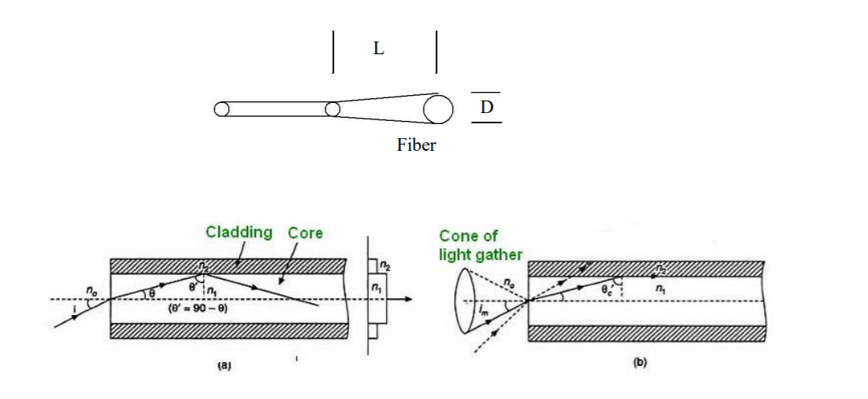

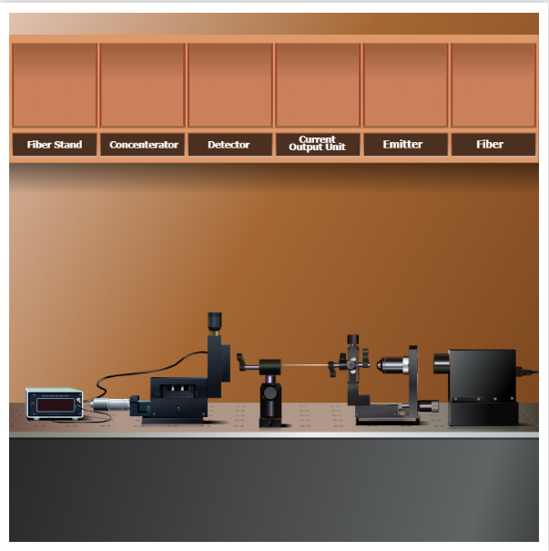

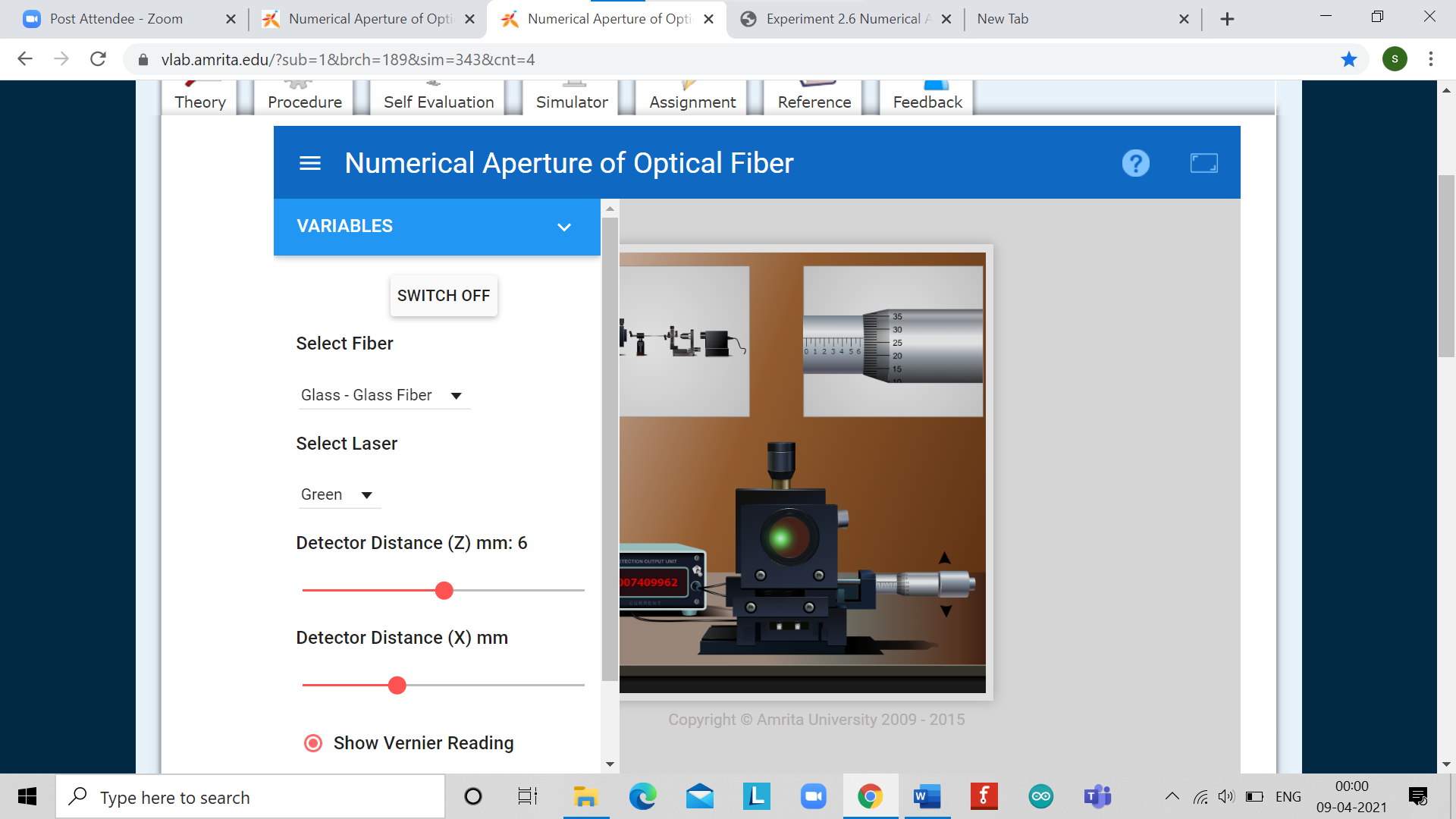

OBSERVATIONS-

Least count of screw gauge

One pitch scale division (n) = 1 mm

Number of divisions on head scale (m) = 100

Least count (L.C) =n/m = 0.01

For distance x formula = (main scale count + circular count *least count)

Detector distance value is constant = 5.8mm

|  |  |  |
| --- | --- | --- |
| Sr.no | Distance x in mm | Detector reading I |
| 1. | 1.05 | 0.00000001 |
| 2. | 2.95 | 0.00000931 |
| 3. | 4.40 | 0.00051776 |
| 4. | 5.75 | 0.00815872 |
| 5. | 6.74 | 0.03412793 |
| 6. | 7.7 | 0.08207196 |
| 7. | 9.35 | 0.12340102 |
| 8. | 10.3 | 0.08207196 |
| 9. | 10.85 | 0.05229091 |
| 10. | 11 | 0.04499559 |
| 11. | 12.05 | 0.01132399 |
| 12. | 13.1 | 0.00160572 |
| 13. | 14.1 | 0.00014659 |

Formula

Numerical aperture = sin θA (acceptance angle)

Imax =pick value of current with respect to distance x/2.71

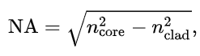

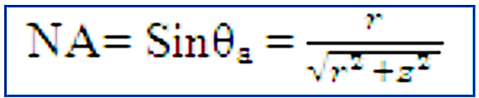

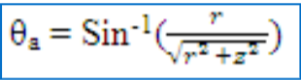

CALCULATIONS-

Distance between the fiber and the detector, d = 5.8 mm

Radius of the spot, r = 1.58 mm

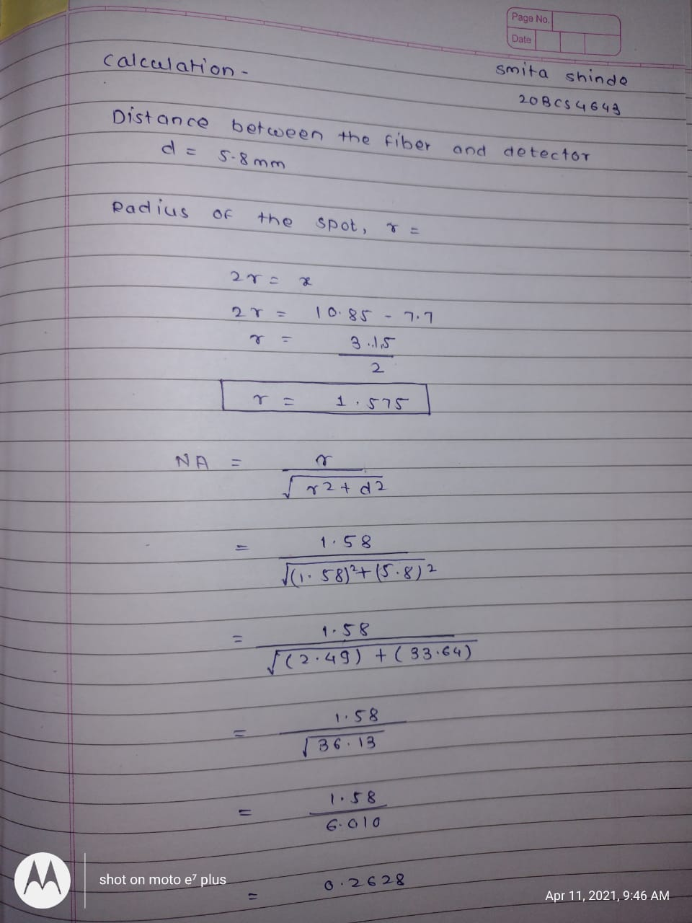

PERCENTAGE ERROR-

No percentage error

GRAPH (ATTACH IF ANY)-

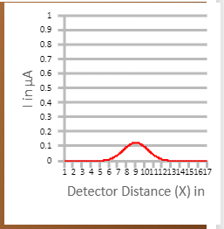

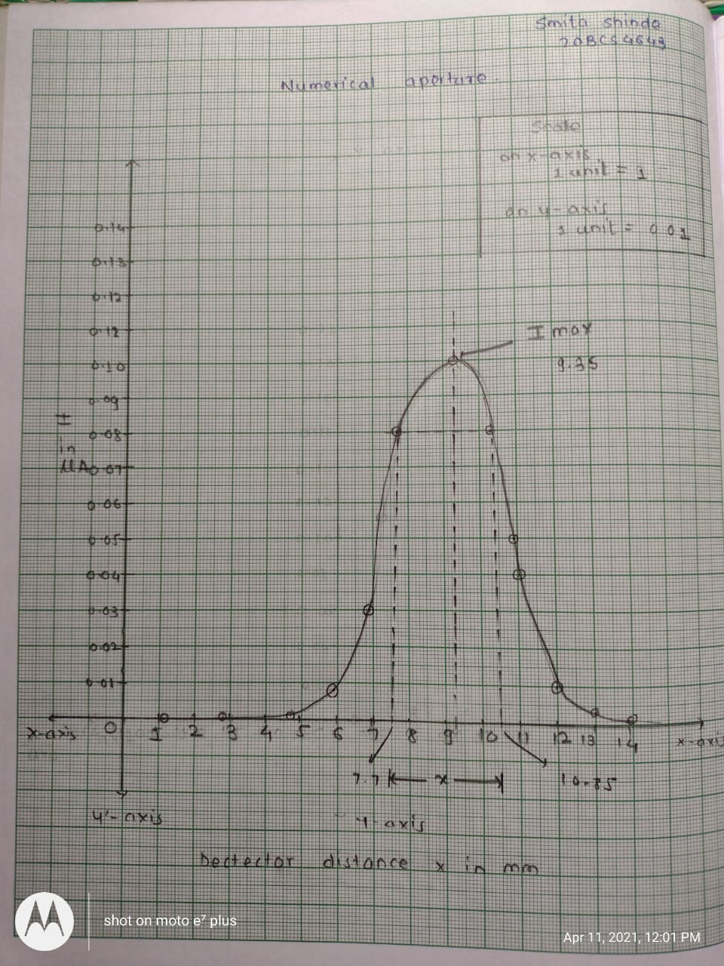

SOURCES OF ERROR-

No any source error

RESULTS AND DISCUSSION-

**Result(s):** Numerical aperture of the given Optical fiber = 0.2628

**Conclusion: -**A high numerical aperture allows light to propagate down the fiber in rays both close to the axis and at various angles, allowing efficient coupling of light into the fiber. However, a high numerical aperture increases the amount of dispersion as rays at different angles have different path lengths and therefore take different times to traverse the fiber. A low numerical aperture may therefore be desirable.

LEARNING OUTCOMES

|  |
| --- |
| * It will provide the modest experience that allows students to develop and improve their experimental skills and develop ability to analyze data. |
| * Ability to demonstrate the practical skill on measurements and instrumentation techniques of some Physics experiments. Students will develop the ability to use appropriate physical concepts to obtain quantitative solutions to problems in physics. |
| * Students will demonstrate basic experimental skills by setting up laboratory equipment safely and efficiently, plan and carry out experimental procedures, and report verbally and in written language the results of the experiment. |
| * Students will develop skills by the practice of setting up and conducting an experiment with due regards to minimizing   measurement error. |

EVALUATION COLUMN (To be filled by concerned faculty only)

|  |  |  |  |
| --- | --- | --- | --- |
| **Sr. No.** | **Parameters** | **Maximum Marks** | **Marks Obtained** |
| 1. | Worksheet completion including writing learning objectives/Outcomes. (To be submitted at the end of the day) | 10 |  |
| 2. | Post Lab Quiz Result. | 5 |  |
| 3. | Student Engagement in Simulation/Demonstration/Performance and Controls/Pre-Lab Questions. | 5 |  |
| 4. | Total Marks | 20 |  |
| 5. | Teacher’s Signature (with date) |  | |